SQL ASSIGNMENT 14

Q1. Write a command that puts the following values, in their given order, into the
salespeople table: city – San Jose, name – Blanco, comm – NULL, snum – 1100.
Ans.

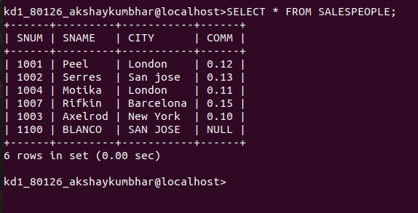

Q2. Write a command that removes all orders from customer Clemens from the
Orders table.
Ans.
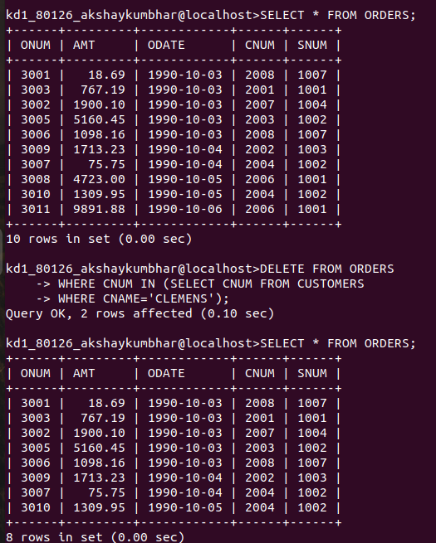

Q3. Write a command that increases the rating of all customers in Rome by 100.
Ans.
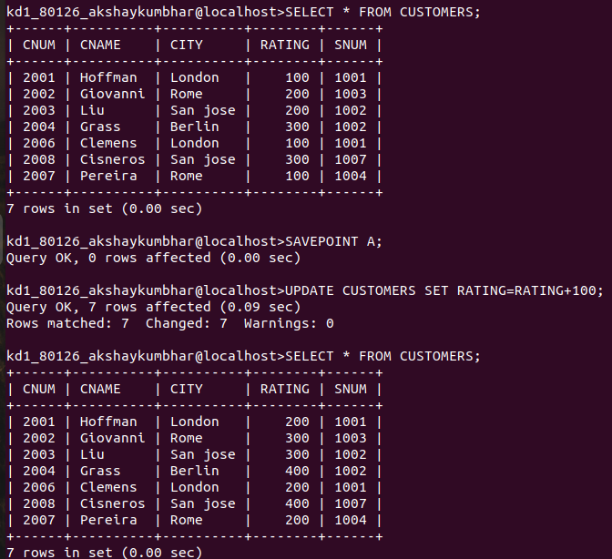

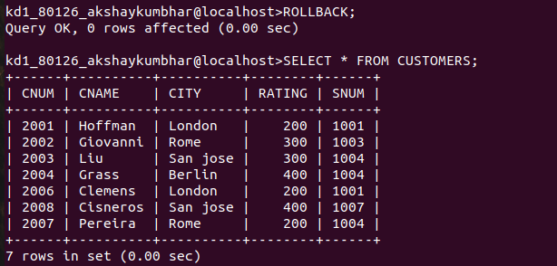

Q4.Salesperson Serres has left the company. Assign her customers to Motika.
Ans.
